User Guide: Ordering Food Online
App Covered: Zomato
Author: Riddhi Khetrapal
Version: v1.0
Date: 25th April, 2026

- Introduction

This guide provides detailed instructions for ordering food using online delivery platforms such as Zomato.
It is designed for first-time users and ensures a seamless ordering experience from app installation to delivery.

- Requirements
Before placing an order, ensure the following:
* A smartphone with Android or iOS
* Stable internet connection (Wi-Fi or mobile data)
* Active mobile number (for OTP verification)
* Installed food delivery application
Why this matters:
This reduces user errors and support issues.

- Step-by-Step Guide
STEP 1: Install & Launch Application
What to do:
1. Open the Google Play Store or Apple App Store
2. In the search bar, type “Zomato”
3. Tap the Install button
4. Once installed, tap Open
Explanation:
This step ensures the user has the official app installed. Avoid third-party downloads.
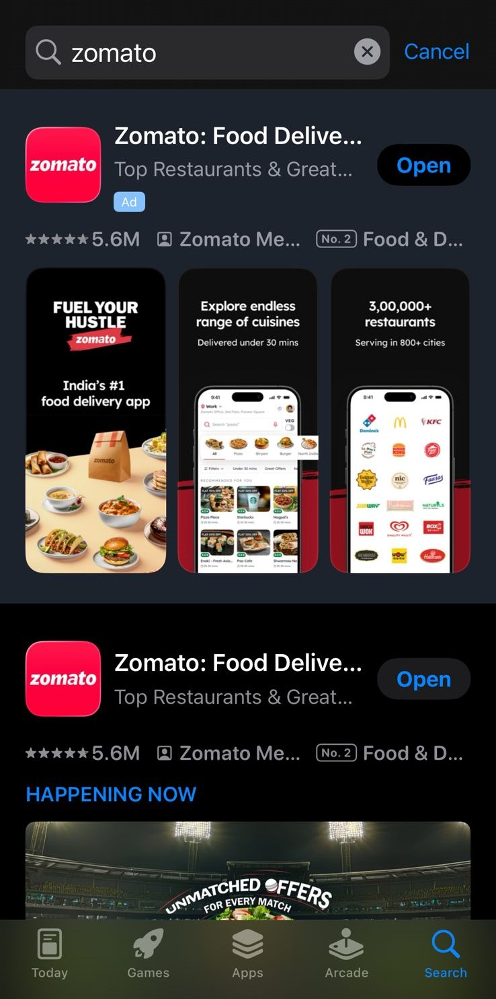
The home screen displays various options such as delivery, dining, and search functionality. Users can begin by selecting the food delivery option and exploring available restaurants.

STEP 2: User Registration / Login
What to do:
1. Enter your mobile number
2. Tap Continue
3. Enter the OTP received via SMS
4. Complete profile setup (Name, Email)
Explanation:
OTP verification ensures secure login and prevents unauthorized access.
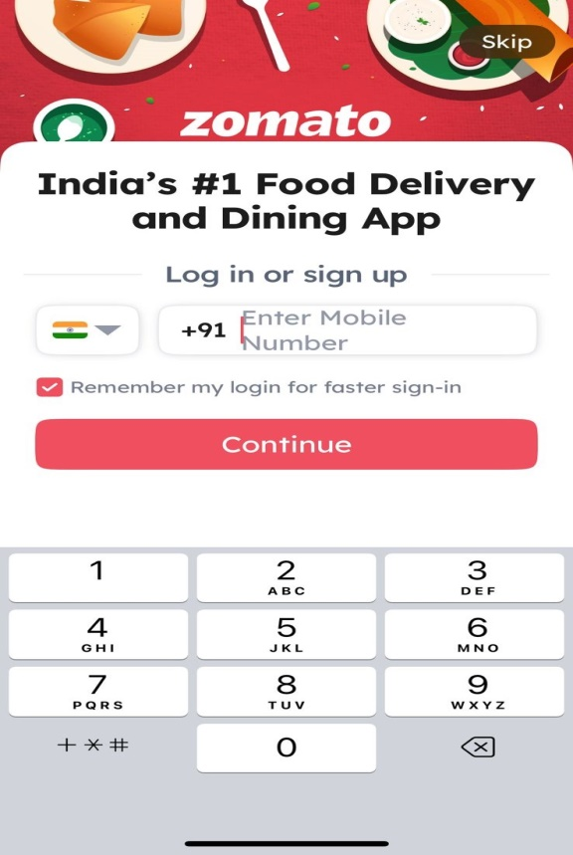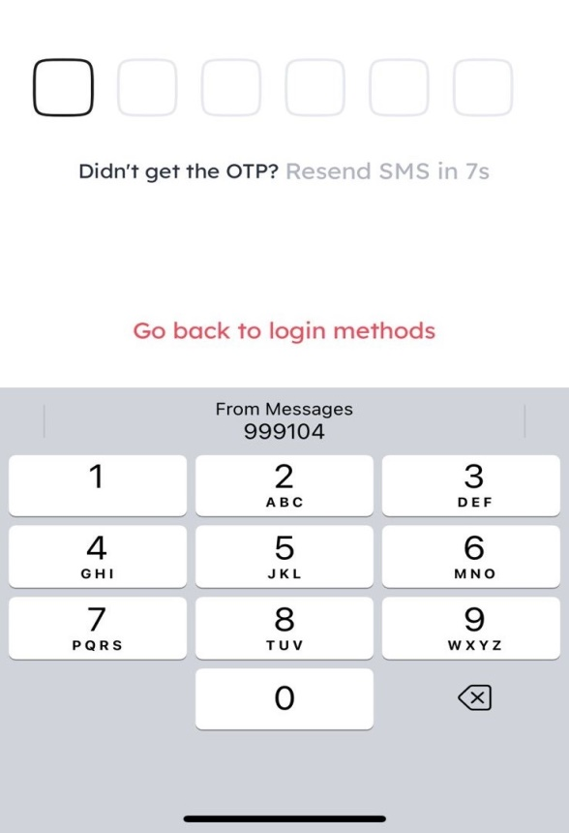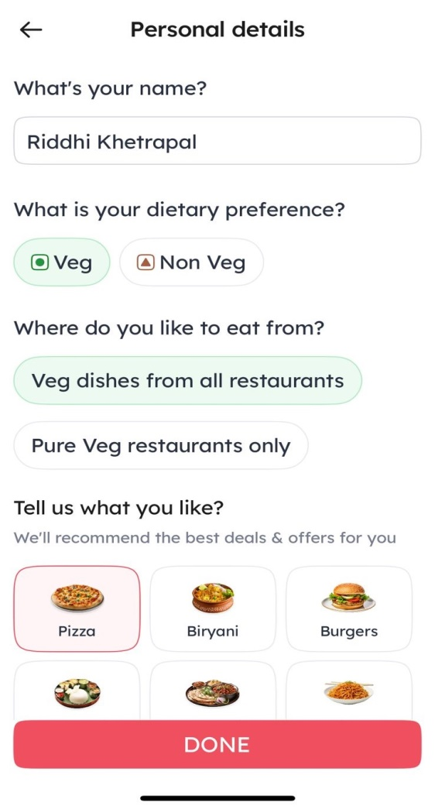
Users must enter their mobile number and verify it using an OTP. This ensures secure access to the application. They should also fill their personal details.

STEP 3: Set Delivery Location
What to do:
1. Allow location access when prompted
2. Select current location OR manually enter address
3. Add details like:
* House number
* Landmark
4. Save address
Explanation:
Correct location ensures accurate restaurant availability and delivery time.
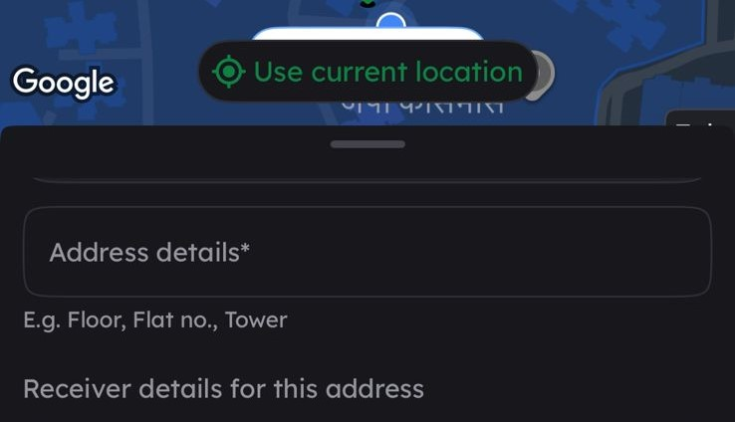
Users can enable GPS or manually enter their address to ensure accurate delivery and restaurant availability.

STEP 4: Search for Food or Restaurant
What to do:
1. Tap on the search bar
2. Enter:
* Dish name (e.g., “Pizza”)
* Restaurant name
3. Browse results
4. Use filters:
* Rating
* Delivery time
* Price range
Explanation:
Filters help users make faster and better decisions.
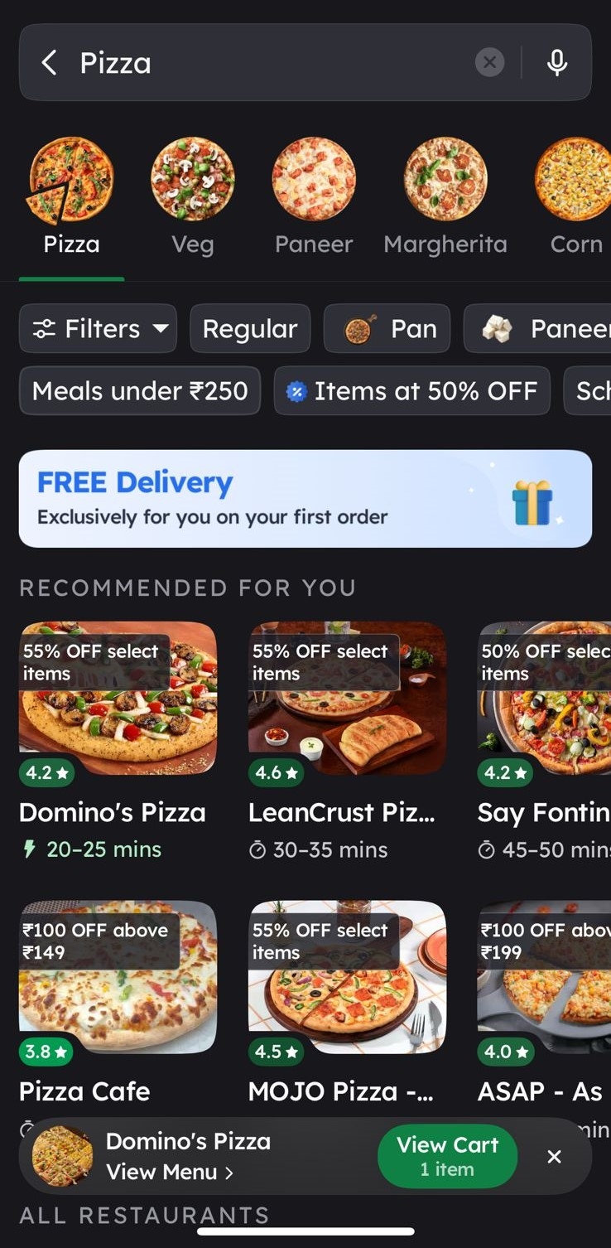
Users can search for dishes or restaurants using the search bar. Filters like ratings and delivery time help refine results.
STEP 5: Select Food Items
What to do:
1. Open desired restaurant
2. Browse menu categories
3. Tap Add next to items
4. Customize (if applicable):
* Quantity
* Add-ons
Explanation:
Customization improves user satisfaction and personalization.
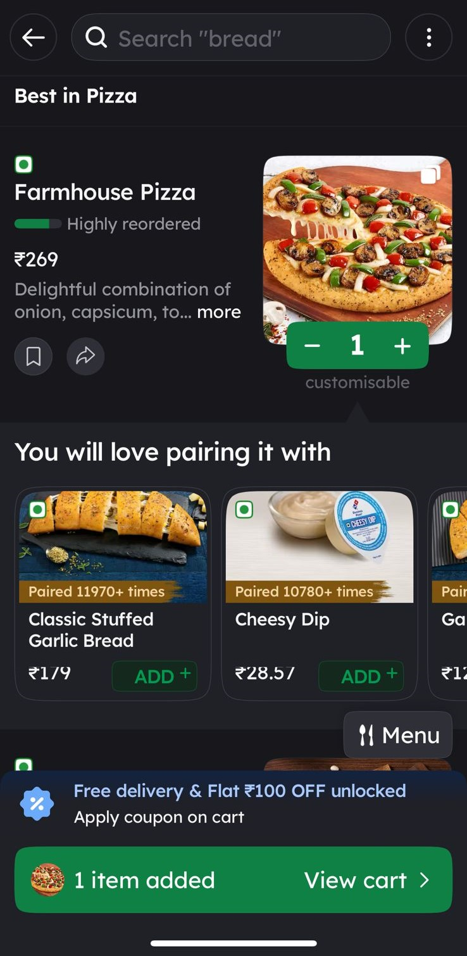
Users can browse menu items, view details, and add items to the cart. Customization options may also be available.
STEP 6: Review Cart
What to do:
1. Open cart section
2. Verify:
* Selected items
* Quantity
* Total price
3. Apply coupon code (if available)
Explanation:
This step prevents incorrect orders and billing issues.
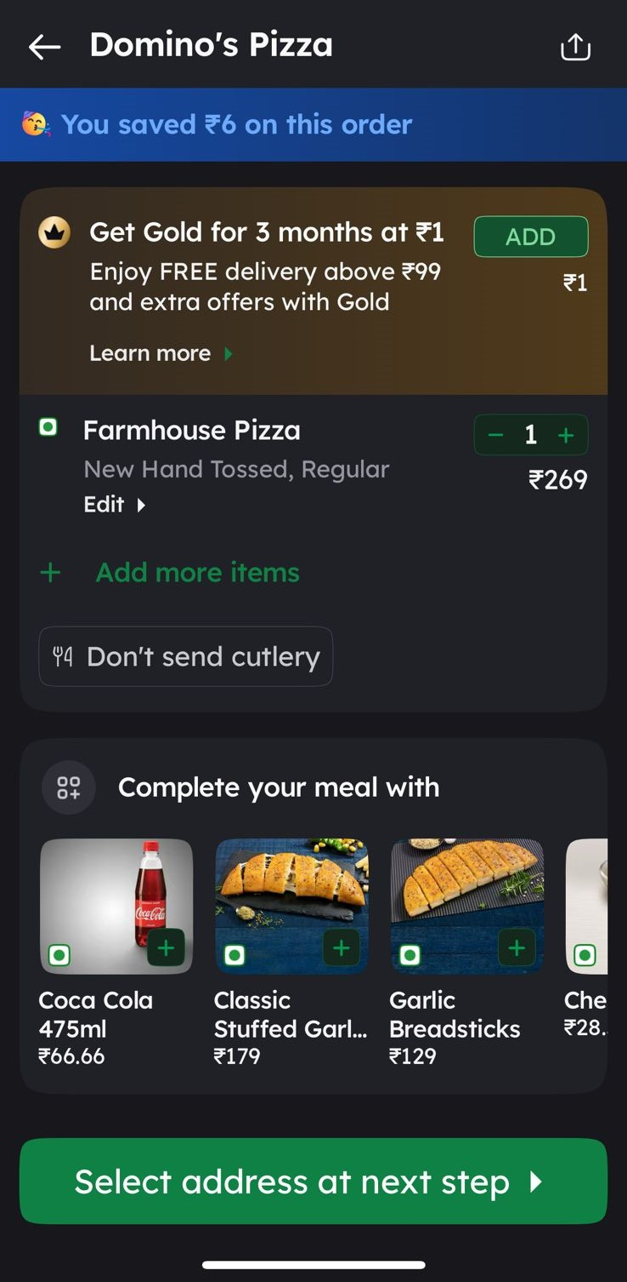
The cart page allows users to review selected items, modify quantities, and apply discount coupons before proceeding.

STEP 7: Checkout & Confirm Details
What to do:
1. Tap Proceed to Pay / Place Order
2. Confirm delivery address
3. Add delivery instructions:
* “Ring bell”
* “Call on arrival”
Explanation:
Delivery instructions improve last-mile delivery success.
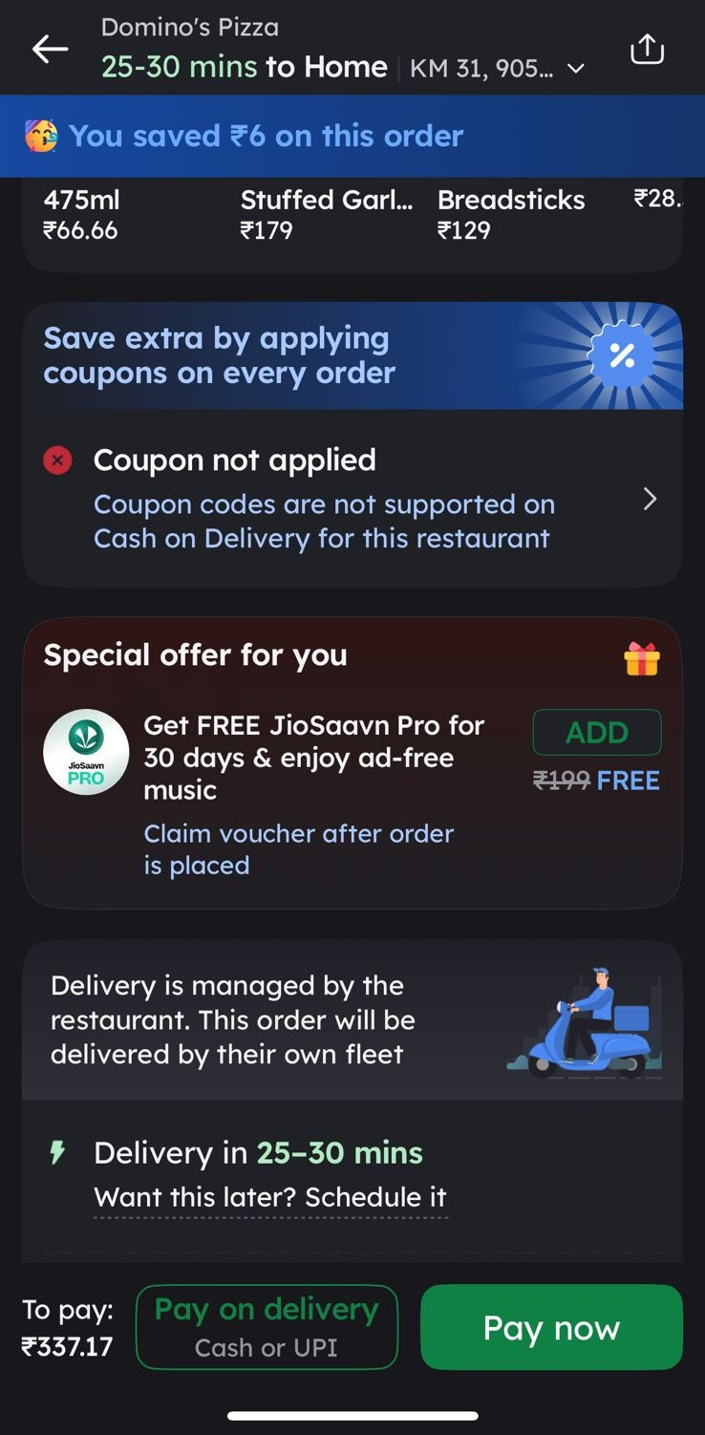
This step allows users to review and confirm delivery details before proceeding with payment.
STEP 8: Payment Process
What to do:
1. Choose payment method:
* UPI
* Card
* Cash on Delivery
2. Complete payment
Explanation:
Multiple payment options improve convenience and accessibility.
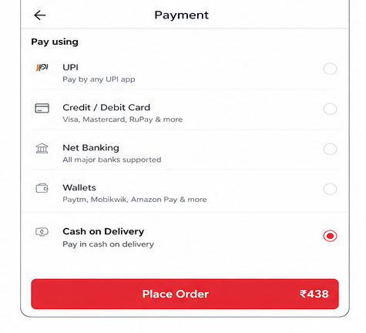
Users select a preferred payment method and complete the transaction securely.

STEP 9: Order Tracking
What to do:
1. View order status:
* Accepted
* Preparing
* Out for delivery
2. Track delivery partner live
Explanation:
Real-time tracking builds user trust and transparency.
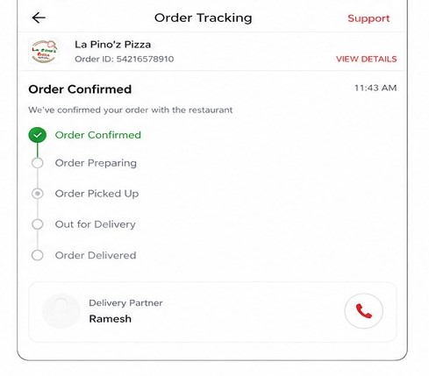
Users can track their order status from preparation to delivery in real-time.

STEP 10: Receive & Verify Order
What to do:
1. Receive order from delivery partner
2. Check items
3. Confirm correctness
4. Provide rating
Explanation:
Verification ensures quality and allows feedback loop.

Upon delivery, users should verify the order contents and provide feedback or ratings.

- Troubleshooting

Issue | Cause | Solution
App crashes | Out-dated version | Update app
Payment failed | Network issue | Retry payment
Wrong item received | Restaurant error | Raise complaint
Late delivery | Traffic / demand | Contact support

- FAQs
Q1: Can I cancel my order after placing it?
A: Yes, but only before the restaurant begins preparation. Refund policies may apply.
Q2: How long does delivery take?
A: Typically 20–45 minutes depending on distance and demand.
Q3: What if my payment is deducted but order not confirmed?
A: The amount is automatically refunded within a few business days.
Q4: Can I schedule an order?
A: Yes, some restaurants allow scheduled deliveries.

- Workflow Summary
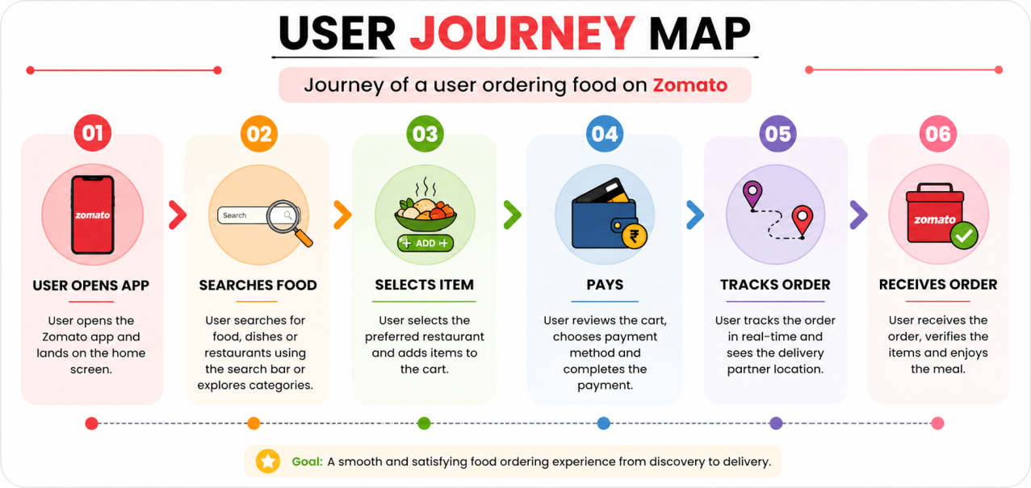
User opens app → Searches food → Selects item → Pays → Tracks → Receives order

- UX Improvements

Suggested Improvements:
- Add “Reorder in one click” button
- Improve error messages (e.g., payment failure clarity)
- Add estimated delivery accuracy indicator

Micro-copy Improvement
Example:
❌ “Error occurred”
✅ “Payment failed. Please try again or use another method.”

Metrics Section
Add:
- Avg order time: 30 mins
- Error rate: (assumed)
- User satisfaction factors

- Advanced Product Improvements

1. Smart Personalization

Problem:
Users see too many options → decision fatigue

Improvement:

Show “Recommended for You” based on:
Previous orders
Time of day
Budget

Example:
“You usually order pizza on weekends – 20% off today”

2. One-Click Reorder

Problem:
Users repeat orders manually

Improvement:
Add “Reorder Last Meal” button on home screen

3. Better Delivery Time Accuracy

Problem:
Estimated time is often inaccurate

Improvement:

Show confidence level

Example:
“Delivery in 30 min (90% accuracy)”

4. Smarter Filters

Problem:
Filters are basic

Improvement:
Add filters like:
“Under ₹200”
“Healthy food”
“Fastest delivery”

5. Real-Time Issue Detection

Problem:
Users only know issues after delay

Improvement:
Show alerts like:
“High demand – delay expected”
“Rain affecting delivery”

6. Improved Error Messages

Problem:
Generic messages confuse users

Improvement:

❌ “Payment failed”
✅ “Payment failed due to network issue. Try UPI or retry in 10 seconds.”

7. Order Editing Option

Problem:
Users can’t modify orders after placing

Improvement:
Allow edit within 2 minutes
Like, add/remove items

8. Live Kitchen Tracking

Problem:
Users only see delivery tracking

Improvement:
Show:
“Preparing food”
“Packing”
“Ready for pickup”

9. Budget Mode

Problem:
Users overspend

Improvement:
Toggle:
“Show only items under ₹X”

10. Voice Ordering

Problem:
Typing takes time

Improvement:
“Order food using voice”
Example:
“Order a veg pizza under ₹300”

- Conclusion
This guide provides a structured and user-friendly approach to ordering food using the Zomato application. It covers the complete process from installation and login to placing an order and tracking delivery, ensuring that even first-time users can navigate the platform with ease.
The inclusion of screenshots, step-by-step instructions, and troubleshooting guidance helps reduce user errors and improves the overall experience. Additionally, suggested UX improvements and advanced features highlight opportunities to further enhance usability, efficiency, and user satisfaction.
Overall, this document not only serves as a practical user guide but also demonstrates an understanding of user behaviour, usability principles, and product improvement strategies.

